Maulik Bhatt

Date:- 07/02/2025 & 10/02/2025

Prometheus monitoring Tool

Contents

Architecture of prometheus 2

MySQL Performance Monitoring: Prometheus vs. MySQL Built-in Tools 3

What Can Be Monitored? (Performance Metrics List) 3

Prometheus vs. MySQL Built-in Performance Tools: Which is Better? 4

Which One Should You Use? 4

✔️ Use Prometheus if: 4

✔️ Use MySQL Built-in Tools if: 5

Final Verdict: Which One is Better? 5

For General Monitoring → Prometheus is Better 5

For Deep Query Analysis → MySQL Performance Schema is Better 5

Recommended Approach for R&D 5

# Architecture of prometheus

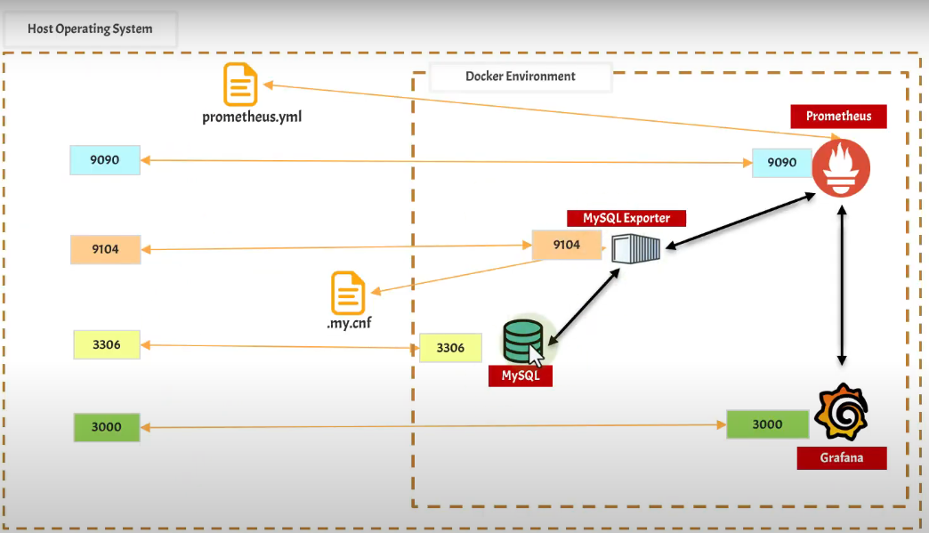

# MySQL Performance Monitoring: Prometheus vs. MySQL Built-in Tools

## What Can Be Monitored? (Performance Metrics List)

| Performance Metric | Prometheus (With mysqld_exporter) | MySQL Built-in Tools (Performance Schema, SYS, etc.) |
| --- | --- | --- |
| MySQL Uptime | ✅ mysql_global_status_uptime | ✅ SHOW GLOBAL STATUS LIKE ‘Uptime’; |
| Active Connections | ✅ mysql_global_status_threads_connected | ✅ SHOW STATUS LIKE ‘Threads_connected’; |
| Total Queries Per Second | ✅ rate(mysql_global_status_queries[5m]) | ✅ SHOW STATUS LIKE ‘Queries’; |
| Slow Queries Per Second | ✅ rate(mysql_global_status_slow_queries[5m]) | ✅ SHOW STATUS LIKE ‘Slow_queries’; |
| CPU Usage | ✅ rate(process_cpu_seconds_total[5m]) | ❌ No direct built-in metric |
| Memory Usage (InnoDB Buffer Pool) | ✅ mysql_innodb_buffer_pool_pages_dirty | ✅ SHOW ENGINE INNODB STATUS; |
| Query Execution Time | ✅ histogram_quantile(0.95, rate(mysql_info_schema_query_response_time_bucket[5m])) | ✅ SELECT * FROM performance_schema.events_statements_summary_by_digest; |
| Max Allowed Connections | ✅ mysql_global_variables_max_connections | ✅ SHOW VARIABLES LIKE ‘max_connections’; |
| Slow Query Log Analysis | ❌ Not available in Prometheus | ✅ SELECT * FROM mysql.slow_log; |
| Disk Usage for MySQL Data | ✅ node_filesystem_avail_bytes{mountpoint=“/var/lib/mysql”} | ❌ No direct built-in metric |
| Replication Monitoring | ✅ mysql_slave_status_seconds_behind_master | ✅ SHOW SLAVE STATUS; |
| Lock Waits & Deadlocks | ✅ mysql_innodb_row_lock_time_avg | ✅ SHOW ENGINE INNODB STATUS; |
| Temp Table Usage | ✅ mysql_global_status_created_tmp_tables | ✅ SHOW STATUS LIKE ‘Created_tmp_tables’; |
| Query Cache Efficiency | ❌ Deprecated in MySQL 8.0 | ✅ SHOW STATUS LIKE ‘Qcache_hits’; (MySQL <8.0 only) |

## Prometheus vs. MySQL Built-in Performance Tools: Which is Better?

| Feature | Prometheus (mysqld_exporter) | MySQL Built-in Tools (Performance Schema, SYS, etc.) |
| --- | --- | --- |
| Real-time Monitoring | ✅ Yes (with a 5s or 10s scrape interval) | ❌ No (only shows snapshots of the current state) |
| Historical Data Retention | ✅ Yes (stores long-term data) | ❌ No (data resets on restart) |
| Graphical Visualization | ✅ Yes (with Grafana or Prometheus UI) | ❌ No (only text-based queries) |
| Query-Level Analysis | ❌ Limited (only pre-defined metrics) | ✅ Yes (detailed query profiling with Performance Schema) |
| Alerting System | ✅ Yes (supports custom alerts) | ❌ No built-in alert system |
| Custom Metrics Support | ✅ Yes (can define custom metrics) | ❌ No (only predefined metrics) |
| Lightweight on MySQL | ✅ Yes (low overhead) | ❌ No (Performance Schema adds some overhead) |
| Complex Query Debugging | ❌ No | ✅ Yes (Performance Schema + Slow Query Log) |
| Integration with Other Tools | ✅ Yes (works with PromQL, Grafana, etc.) | ❌ No (MySQL-specific only) |

## Which One Should You Use?

### ✔️ Use Prometheus if:

* ✅ You need real-time monitoring and alerting.
* ✅ You want to track long-term performance trends.
* ✅ You need an external monitoring system that doesn’t slow down MySQL.
* ✅ You are working with DevOps tools and want easy integration.

### ✔️ Use MySQL Built-in Tools if:

* ✅ You need detailed query-level analysis.
* ✅ You want to debug slow queries and locks.
* ✅ You need deep insights into query execution plans.
* ✅ You don’t want to set up an external monitoring system.

## Final Verdict: Which One is Better?

### For General Monitoring → Prometheus is Better

* Great for real-time metrics, alerting, and long-term storage.
* Less impact on MySQL performance.

### For Deep Query Analysis → MySQL Performance Schema is Better

* Best for query optimization, deadlock detection, and detailed execution statistics.
* More useful for DBAs and developers troubleshooting slow queries.

## Recommended Approach for R&D

Since you are doing R&D, the best approach is:

1. Use Prometheus to monitor overall MySQL health (CPU, queries/sec, slow queries, memory).
2. Use MySQL’s Performance Schema when you need deep query-level insights (execution time, locks, indexing issues).
3. Use MySQL Workbench for graphical performance reports and query tuning.